## **CSY2085 – Server Administration and Security**

## **Workshop 4 - Windows Server as an Internet Server**

STUDENT NAME: Muhammad Raza

STUDENT NUMBER: 21624838

**Task 1 – Setting Up WAMP**

1. **Question: What does UAC do? Explain its function on Windows.**

**User Account Control (UAC) is a Windows security feature that prevents unauthorized changes to the system by prompting for administrative approval for actions requiring elevated privileges. It helps separate standard user and administrator activities, reducing the risk of malware and accidental system changes. UAC prompts users for consent or credentials before allowing significant system modifications. It also enhances security awareness and encourages best practices. UAC's adjustable settings allow users to customize the level of notification and protection.**

1. **Question: Why did we change the port that Apache is listening on, from the default for HTTP, port 80, to port 100? (Hint: What did we install in Workshop 3?)**

We changed the port that Apache is listening on from the default port 80 to port 100 to avoid conflicts with other services that might be using port 80. This can also be a security measure to obscure the service from automated attacks targeting default ports. Additionally, using a non-standard port can help in development and testing environments where multiple services need to run simultaneously without interference. This change also allows running the server without requiring administrative privileges, which are needed for binding to ports below 1024. Lastly, it can help in network segmentation and management in complex network setups.

## Task 2: Starting Apache and MySQL

1. Take a screenshot of the XAMPP window, and paste it below:

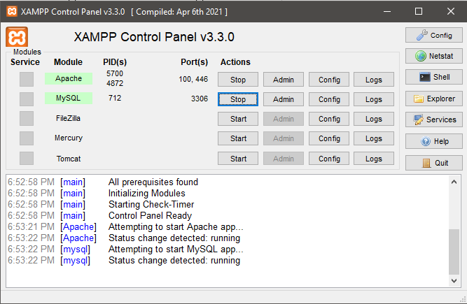

1. Take a screenshot of the window and paste it below:

**Change firewall to allow port 100**

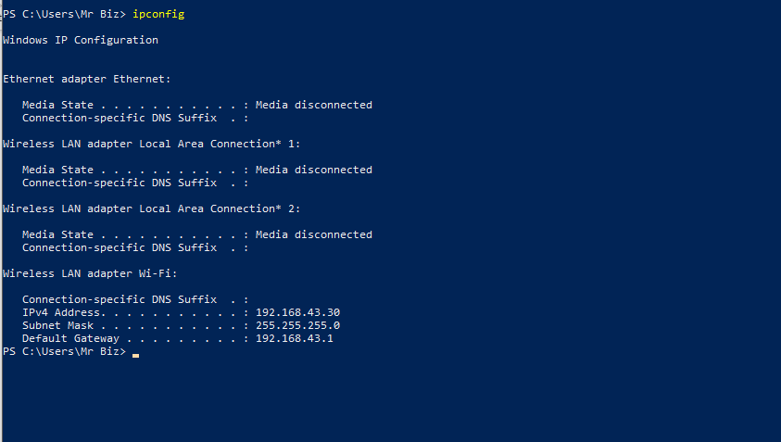

1. Take a screenshot of the screen you see, like the following:

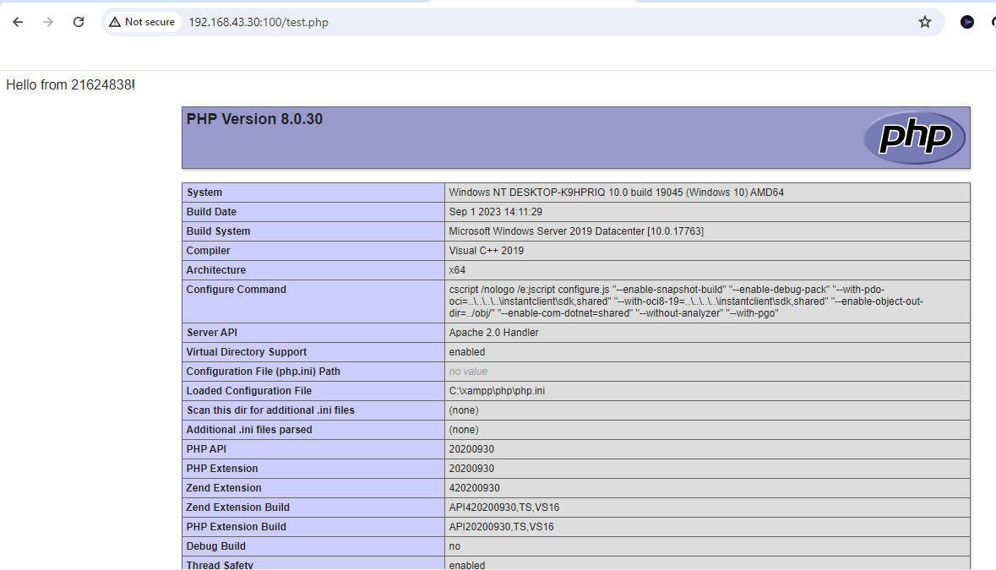

## Task 3: PHPMyAdmin

1. The next screen should show the data has been inserted into the database. Take a screenshot, and paste it below:

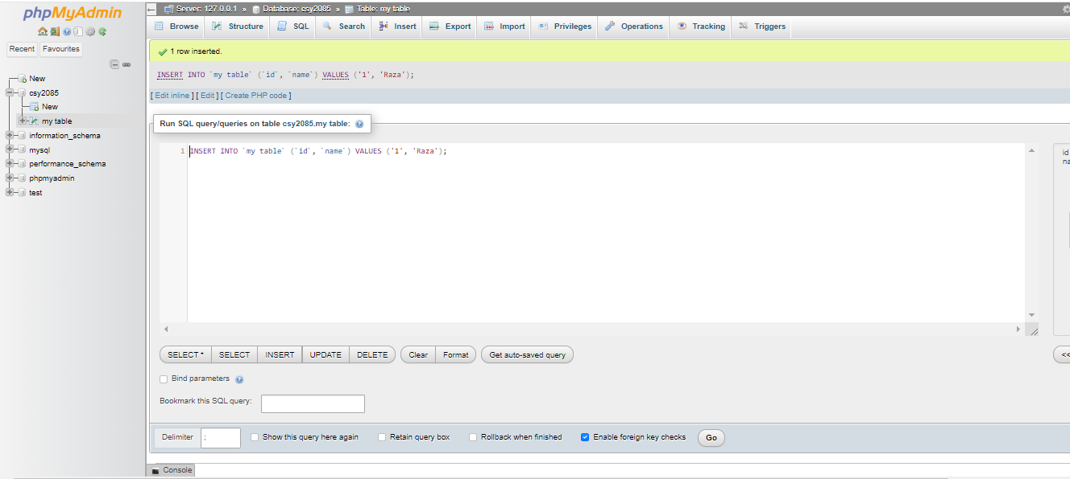

## Task 4: Testing MySQL

1. Take a screenshot of the page, and paste it below:

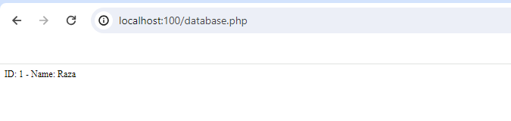

1. **Question: What was the default username and password for connecting to MySQL? (Check the PHP code)**

The default username and password for connecting to MySQL in the provided PHP code are:

**Username:** root

**Password:** (empty string)

1. **Question: In the context of software, what does “Production Ready” mean? Do you think the default username and password for MySQL would be secure enough to be ‘production ready’? How could it be improved?**

"Production Ready" in the context of software means that the application is stable, secure, and suitable for deployment in a live environment where real users interact with it. The default MySQL username (**root**) and an empty password are not secure for a production environment. To improve security, use a strong, unique password for the MySQL **root** user, and create separate MySQL users with the least privileges necessary for each application or task.